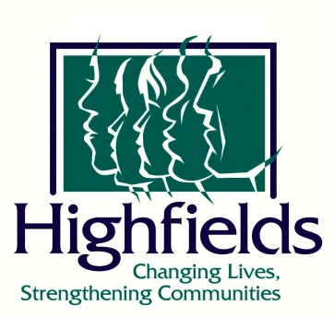
CONTACT: Emily Morgan FOR IMMEDIATE RELEASE
Communications and Marketing Specialist
emorgan@highfields.org

Granger Foundation awards $150,000 to Highfields Trauma Informed Campus Designs

Onondaga, Michigan – May 28, 2021 – Highfields Inc., a multi-purpose human services organization for children and families, was awarded a grant of $50,000 over the next 3 years, equaling $150,000, by the Granger Foundation for Highfields Trauma Informed Campus infrastructure and treatment.

“Highfields partnership with the Granger Foundation has been an important component of our community support. The Granger Foundation‘s commitment to children and families has made mid-Michigan a better place for everyone,” said Brian Philson, Highfields’ President and CEO.

Funds from the Granger Foundation will help enhance trauma-informed treatment and improve infrastructure for the benefit of youth and families in Highfields’ programs. Agency wide enhancements will include replacing signage agency-wide, and parking lot upgrades for the Lansing Office. On campus, renovations will include upgrades to the student weight room, furniture, generators and insulation, installations of trauma-informed murals in student houses, and LED lighting in the Jean Schultz Center.

Highfields is a nonprofit human services organization which provides home-based counseling, residential care for young men ages 11-17, and experiential education and support programs for children, youth, and families in 13 mid-Michigan counties. For more information, please visit www.highfields.org.
###

