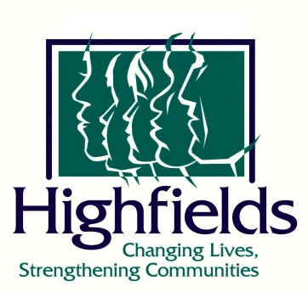
CONTACT: Emily Morgan FOR IMMEDIATE RELEASE
Communications and Marketing Specialist
emorgan@highfields.org

Jackson National Life Insurance Company awards $10,000 for Family Preservation Project

Lansing, Michigan – June 1, 2021 – Highfields Inc., a multi-purpose human services organization for children and families, was awarded a grant of $10,000 from Jackson National Life Insurance Company (Jackson®) to further our work of family preservation. With this support from Jackson, the Family Preservation Project will assist families with immediate needs that threaten their stability while receiving treatment from Highfields’ programs.

“Our work with preservation of the family is crucial to our mission, and we are truly excited to have Jackson National’s partnership as we serve mid-Michigan,” said Brian Philson, Highfields’ President and CEO.

The Family Preservation Project assists with important resources that may not be readily available, such as diapers, transportation, supplies for children with special needs and similar items and services. The project also provides assistance with the payment of utility bills and security deposits that have become overwhelming for families struggling to make ends meet.

“Jackson’s local community grants give priority to strengthening families and creating economic opportunities for people in the places we call home,” said Danielle Robinson, Assistant Vice President of Corporate Philanthropy, Jackson. “We are grateful for our longtime partnership with Highfields and continue to be impressed by the good work they do year after year.”

Highfields is a nonprofit human services organization which provides home-based counseling, residential care for young men ages 11-17, and experiential education and support programs for children, youth, and families in 13 mid-Michigan counties. For more information, please visit www.highfields.org.
Jackson is committed to helping clarify the complexity of retirement planning for its customers. Jackson’s range of annuity products, financial know-how, history of award-winning service, and streamlined experiences strive to reduce the confusion that complicates retirement plans. As part of its award-winning Corporate Philanthropy efforts, Jackson operates a competitive grant program in the local communities where its employees live and work.

###

